Westgate Park Lakes

The two lakes were sampled 3 May 2019 in order to determine the organism(s) responsible for the pink colour of the Salt Lake.

A dip sample was collected from the shore, also a sample containing some bottom mud. A 35 micron mesh plankton net was used to collect a more concentrated sample but this was deemed unnecessary as the concentration of organisms in the dip sample was sufficient for the purpose of microscopic examination.

Lugols iodine was added to a portion of the net sample to preserve any flagellate algae such as Dunaliella salina which may have been present.

Salt Lake Westgate Park

The samples as collected, were photographed later that afternoon. The abundant and dominant organism in the sample is shown in Figure 2 and was identified as a purple sulphur bacteria, probably Chromatium sp. Figure 3 was taken from the internet and appeared to confirm the identification. The cells are packed with sulphur granules.

There were other organisms present, including many microscopic bacteria, but nothing which could be satisfactorily identified apart from the occasional cell of Dunaliella (Figures 4 and 5).

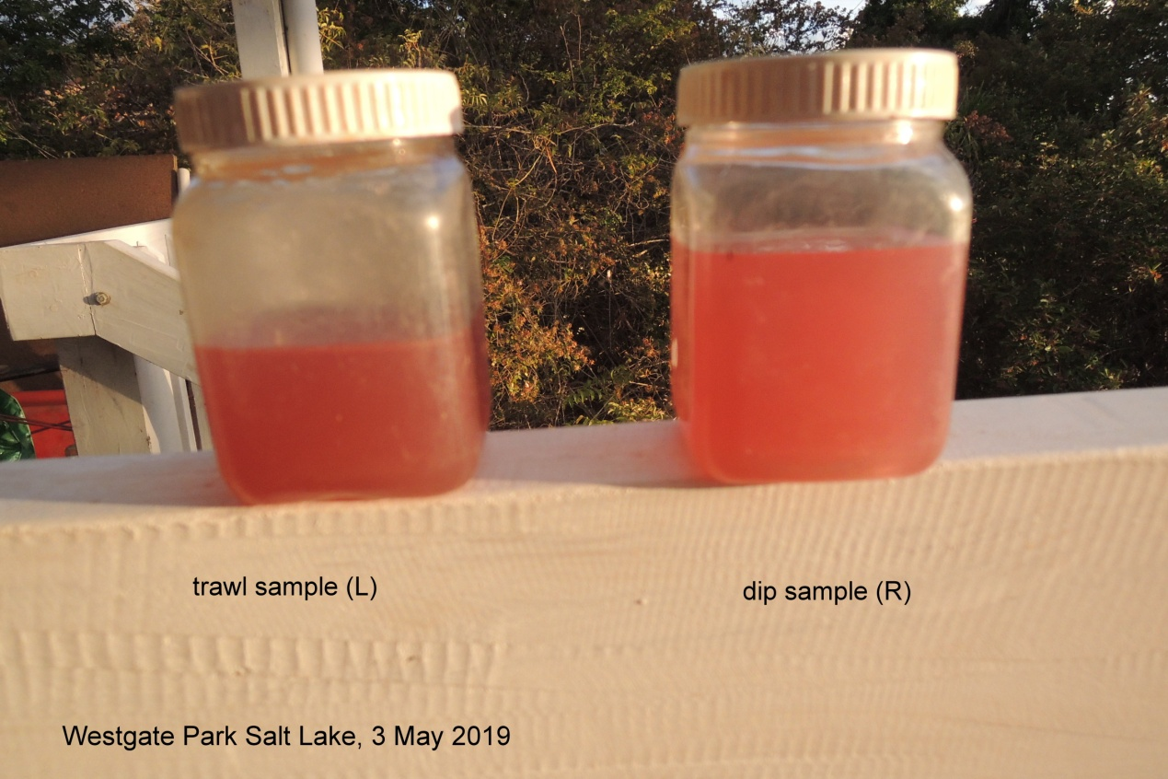
Figure 1: Samples as collected, 3 May 2019
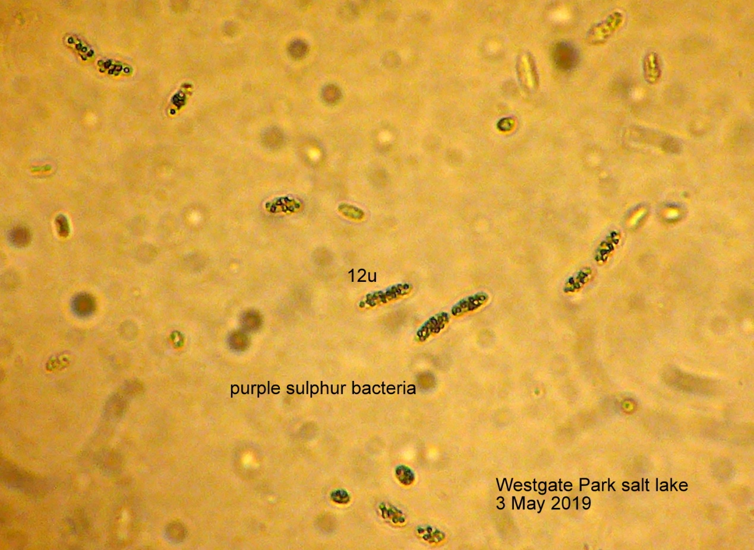
Figure 2: Purple sulphur bacteria (photographed at x400 magnification)

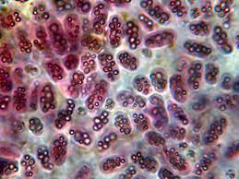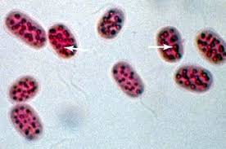
Figure 3: Two images from internet Phycokey - Purple Sulfur Bacteria images
http://cfb.unh.edu/phycokey/Choices/Anomalous_Items/bacteria/Photosynthetic%20bacteria/Purple%20sulfur/Purple_sulfur_Image_page.html

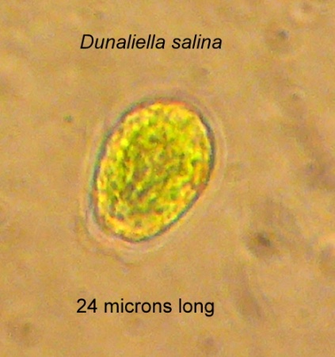
Figure 4: Dunaliella salina prior to addition of Lugols iodine (x400)
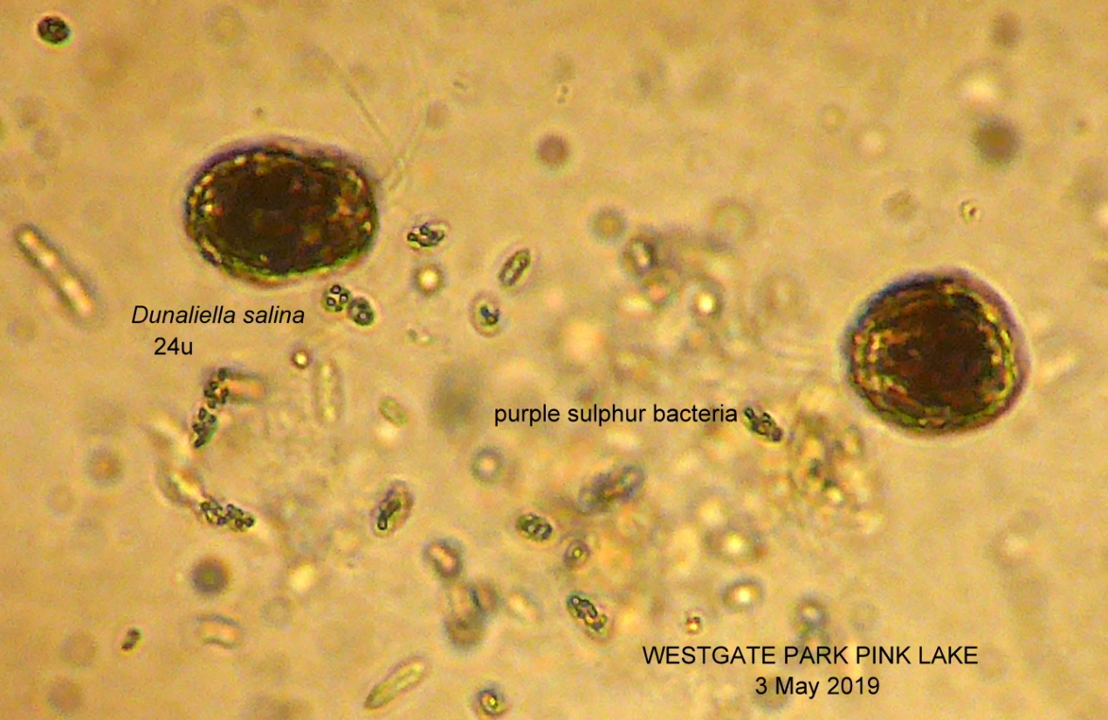
Figure 5: Dunaliella and purple sulphur bacteria in trawl sample from Salt Lake
(preserved with Lugols iodine - note the 2 flagella on top left Dunaliella cell x400)

Also collected was a clump of filamentous cyanobacteria (blue-green algae) which had become dislodged from the sediments and was floating past. It contained several different filaments including the filamentous sulphur bacteria Beggiotoa (also packed with sulphur granules) and also some halophile diatoms (Figure 6).

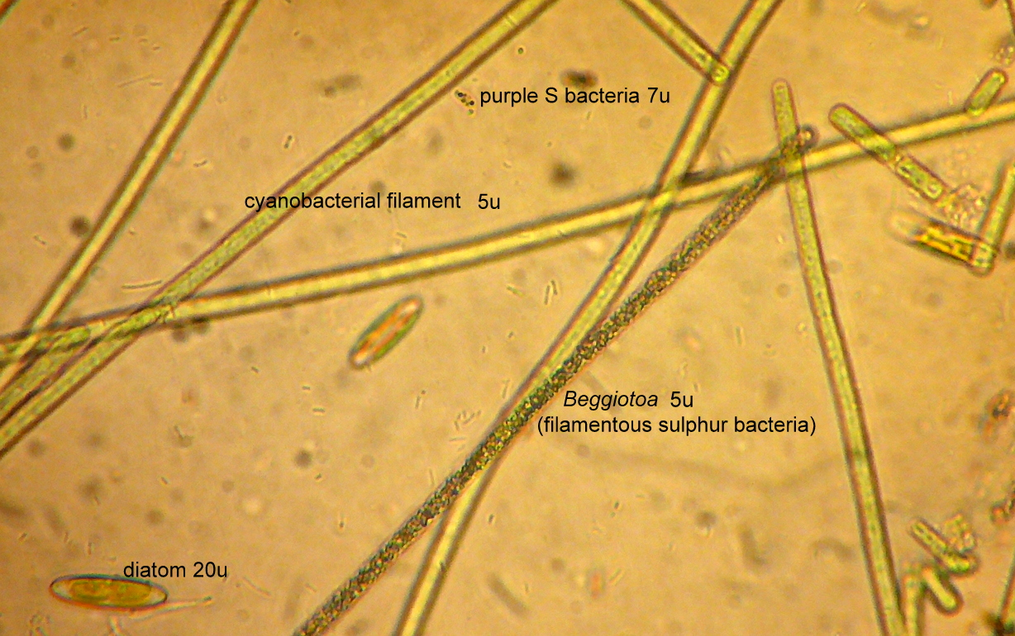Figure 6: Filaments in algal mat dislodged from sediments
Freshwater Lake, Westgate Park

A net sample contained an abundance of large zooplankton (Figure 9) mostly Daphnia with a few copepods and the occasional ostracod. Rotifers were also present but rare. The emergent plant is Ruppia sp. a native perennial found in lakes of elevated salinity.

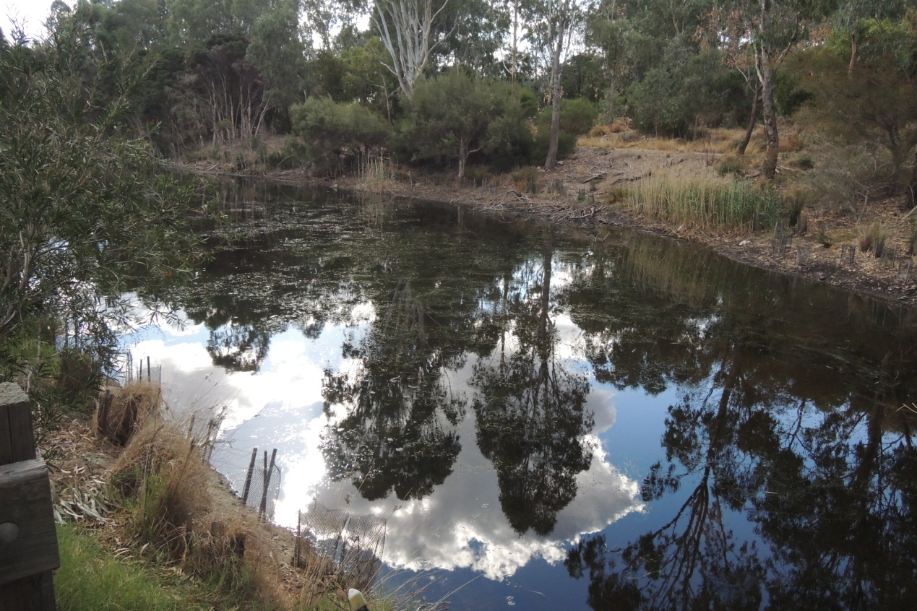
Figure 7: Beds of emergent macrophytes (Ruppia sp.)

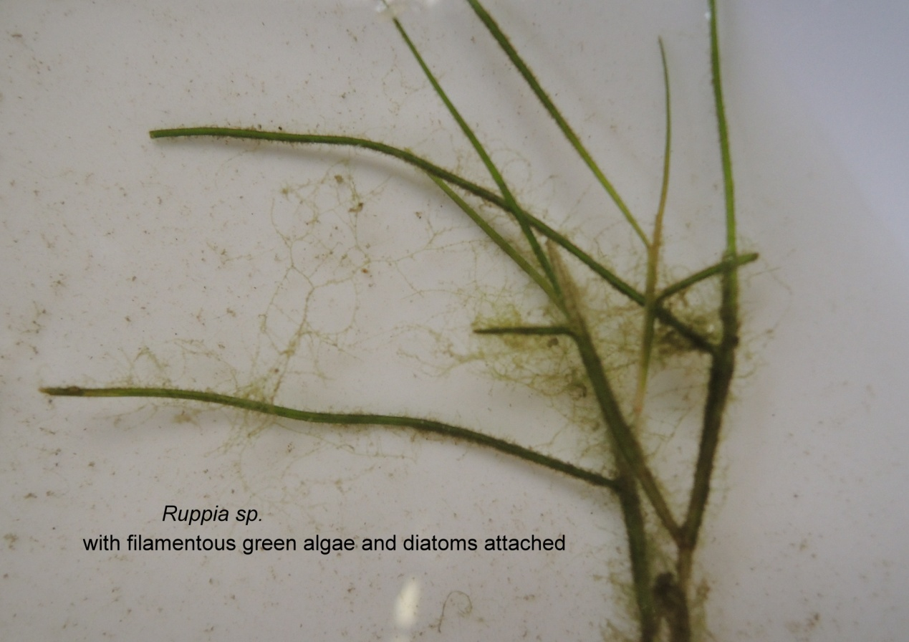
Figure 8: Filamentous green algae attached to Ruppia stems
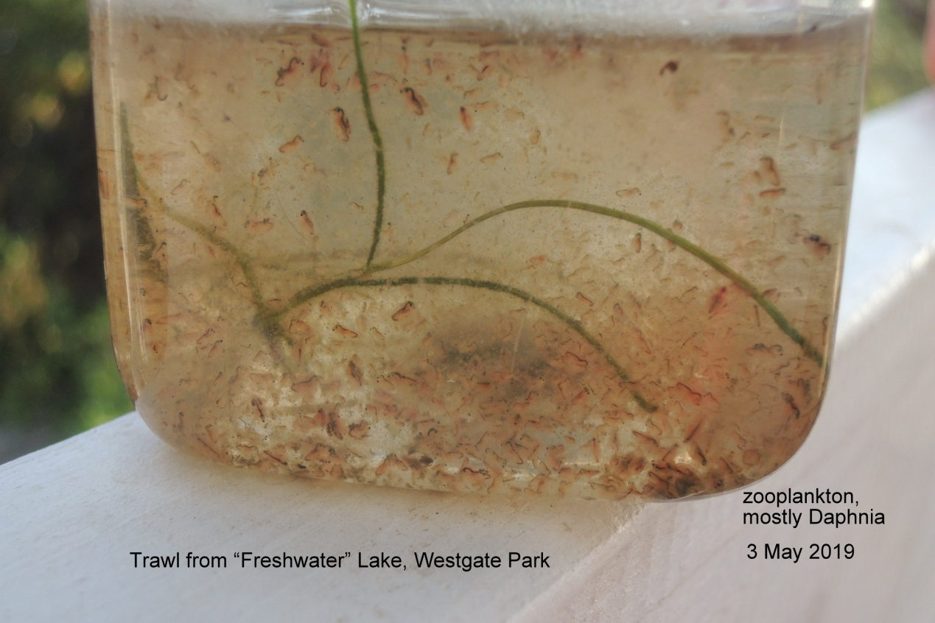
Figure 9: Single trawl (30 micron mesh net). Large animals are Daphnia carinata. Pink colour (haemoglobin) may indicate oxygen stress

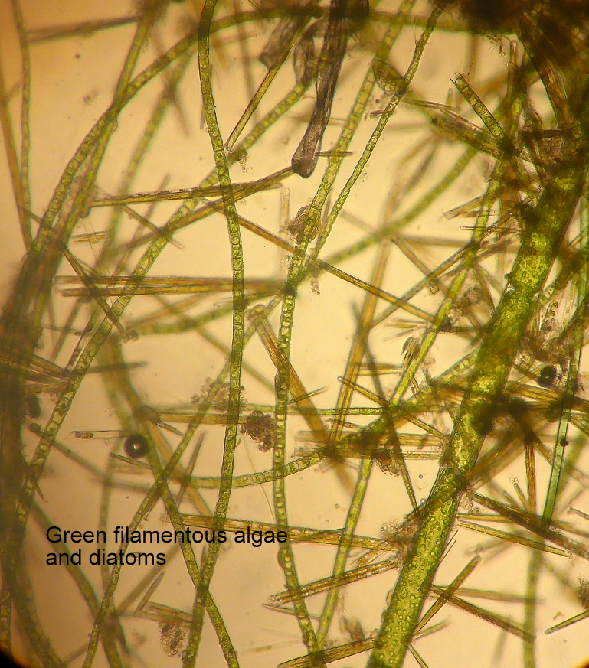
Figure 10: Various green filamentous algae (x100) draped on Ruppia stems

Joan Powling
Ivanhoe 6 May 2019

