Annual report 2023-2024

Management of Westgate Park
The City of Melbourne to take up management of Westgate Park on 1 January 2026. The preparation for the transfer has begun with talks in April and a workshop involving the committee and volunteers.
I acknowledge the efforts made by former Lord Mayor Sally Capp in driving this move. She was a good advocate for the change, strongly encouraged by another former Lord Mayor, our Lecki Ord, who has for many years been a member, a wise counsel, an excellent planner, organiser and committee member for Westgate Biodiversity. We miss her.
The City of Port Philip require us to vacate the Williamstown Road nursery site also on 1 January 2026 so we face some critical deadlines and uncertainty about how the new compound/nursery will be funded.
We met with Andrew Kelly at Parks Vic quarterly, with updates on issues such as the state of toilets and an ongoing plea for more regular mowing to stem the spread of weeds. Weeds have now invaded many areas of the Park, particularly sections most recently planted, however our work crews are making big inroads, clearing areas.
A word about George Fotheringham
For more than 20 years George led the work to turn a shamefully neglected Westgate Park into one with the greatest biodiversity riches imaginable in the middle of Melbourne. His plant knowledge and his drive to bring back nature was endless. We don’t see much of George in the Park these days and I know that if he could, he would be there.
Bili Nursery
Rhod Cunningham, our manager, has transformed Bili Nursery, expanding the range of seed collected and species propagated, the customer reach and the drive for improving successful plant development. For instance, trials of Alyxia buxifolia increased production by 40% and Correa reflexa and Correa alba by 30%.
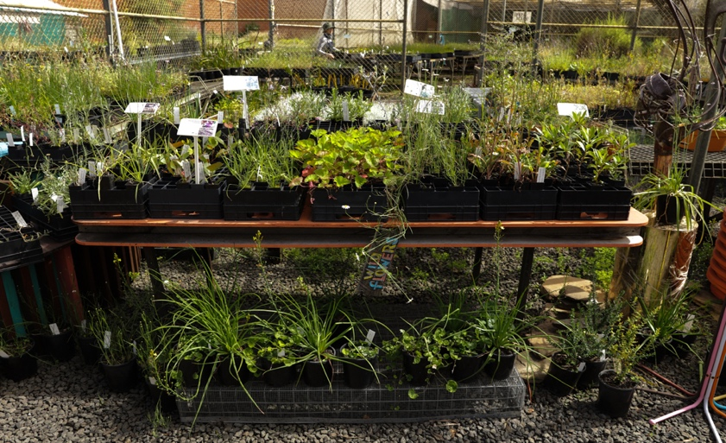

There is a growing demand for indigenous plant species as councils and landscapers recognise the importance of biodiversity. We were approached to ‘revitalise’ Gasworks Park with indigenous plants. Our retail trade has more than doubled this year thanks to a concerted effort by Amy Denyer on Insta and Maggie in a rejuvenated ‘shop’.

We are using a section of the Wharf Road Triangle to grow plants on, however, operating from 2 sites and lack of nursery space severely limits our capacity to supply.

While Westgate Park is still an important source of seed, the Bili Nursery team now has permission to collect ~100 species from sites well beyond the Melbourne region such as the Brisbane Ranges, Anglesea, Bacchus Marsh, the Macedon Ranges. This means our seed room is well stocked but, as always, we rely on working bees and volunteers to help us with seed cleaning. Grey Cat deserves a mention as Chief Mouser, without whom our baby plants would be at great risk.

This year new connections were made and tours taken to Angair, the Cranbourne Botanical Gardens, the Euroa Arboretum, and the Goulburn Catchment seed collection and the Brisbane Ranges groups. Closer to home, we planted the Victoria Harbor Urban Forest – a space surrounded by tall buildings, opened by the then Lord Mayor Sally Capp. We hosted Gardens for Wildlife workshops for the City of Port Phillip and Birding Australia collaborated with us for an online gardening course with Mars Reid and Emma Cutting.

We now have an extensive data base of the landscape industry and our enewsletters are generating business but we have had to knock back big orders because of space restraints.

In November we agreed to hold a spring sale/festival in Westgate Park (very successfully held in October 2024 on as part of Riverfest).

Citizen science at Bili Landcare
The Hollows for Habitat project resumed at Westgate Park in earnest at the beginning of the year. A core team enthusiastic people are monitoring the boxes and recording the microbat echolocation calls around the Park. So far, we have found just one microbat in our boxes but recorded calls on all our nocturnal walks – all from the Gould’s Wattled Bat.

Of course bird surveys are still being held monthly thanks to Rob Youl and his team of Peter Parrington, Rob Youl, Lyn Griffen, John McRae, Elke Link and Andrew McCutcheon with a special mention for our bird and other creatures photographer, Ursula Dutkiewicz.

Security
At Westgate Park thieves stole copper from the former Herald & Weekly Times building next door and discovered some of our valuable equipment - a trailer, chainsaws, brushcutters etc - were taken. The community rallied raising $5k for a new trailer and $3.4k for wheel locks and security systems. Go fund me raised $2.5k.

Snippets from the Park
We were excited to see the Grey Mistletoe flower for the first time and the Drooping Mistletoe growing. Water levels remain fairly high so our aquatic plants are doing well as are our saltmarsh plants and our remnant vegetation.

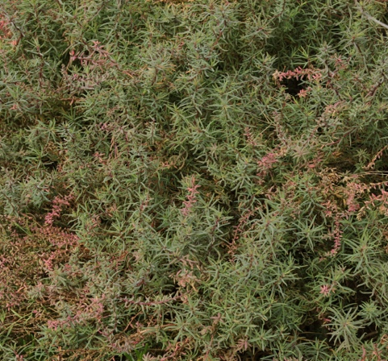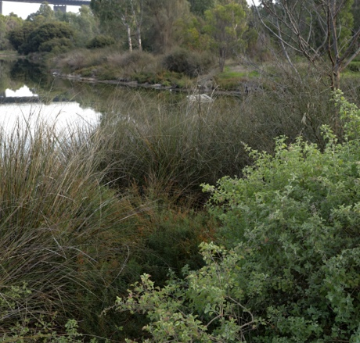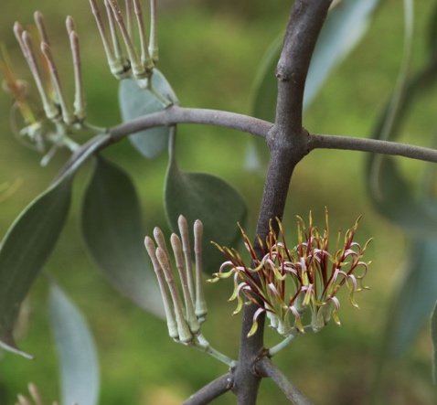
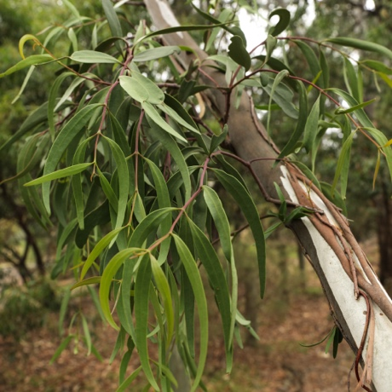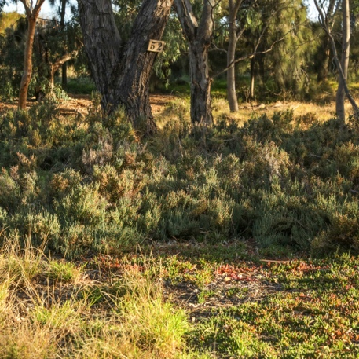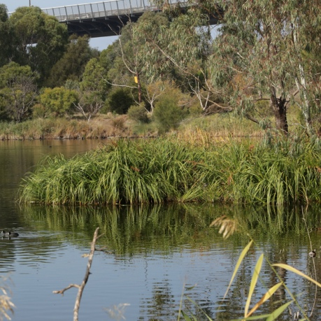

Engagement with local schools
We worked with Port Melbourne Secondary College on their Evolve program and Albert Park Secondary College students came to the Park for a week of biodiversity activities early in the year. Melbourne Grammar Year 9s helped us out with weeding in 1st heath.

Corporates
A steady stream of corporate groups came to both Bili Nursery and Bili Landcare, bringing funds and lots of energy, expertly coordinated by Andrea Garcia.

Thank you to our current Committee of Management:
- Duncan Fitzpatrick for overseeing grants
- Linda Lucas for her organising the nest box project such enormous enthusiasm
- Ana Backstrom helping with ecological advice, particularly weed management guidelines.
- Angelo Indovino assisting our treasurer with finance
- Rosey Haas as Treasurer and the first to volunteer with spraying and cleanups
- Chris Stephen who joined in October last year, no doubt thinking he was retiring, now leads our amazing work crew and and liaison with Parks Vic.
- Amy Denyer who did a great job in assisting with social media – we will be sorry to see you go
- Janet Bolitho doing a sterling job as secretary and her always wise counsel
- Dave Knott is a Wednesday worker and very useful finance adviser

With special thanks to our dedicated staff and regular volunteers:
Bili Nursery: Staff - Rhod, Mars, Maggie, Matthew and volunteers – Nic, Nick, Paul S, Paul K, Phoebe, Ro, Ruth, Sofia, Susan, Tiger, Van, Veronica, Victoria, Vinoth, Vishna, Will, Zehao, Zoe B and Zoe H.

Bili Landcare: Jackie, Andrea, Chris, Lorraine, Mark, Bruce, Malcolm, Van, Ruth, David, Graham, Stef, Bonny, Janine

And thank you to our many other friends:
- ACF Macnamara who come to the Park regularly to weed and plant.
- Tangaroa Blue who regularly clean up on the riverbank
- Rotary Albert Park who funded what was an expensive chemicals cabinet, without which we would not be allowed to spray.

